LAB 2

HRITIK AJAY BANSAL

CSE A 14

180905105

Q1)

<!DOCTYPE html>

<html>

<head>

<title>Student biodata form</title>

<meta charset="utf-8">

<meta name="viewport" content="width=device-width, initial-scale=1">

<link rel="stylesheet" href="https://maxcdn.bootstrapcdn.com/bootstrap/3.4.1/css/bootstrap.min.css">

<script src="https://ajax.googleapis.com/ajax/libs/jquery/3.5.1/jquery.min.js"></script>

<script src="https://maxcdn.bootstrapcdn.com/bootstrap/3.4.1/js/bootstrap.min.js"></script>

</head>

<body>

<div class="container">

<form action="/action_page.php">

<div class="form-group">

<label>Name:</label>

<input type="text" class="form-control"id="usr">

<label>Semester:</label>

<input type="text" class="form-control"id="sem">

</div>

<br>

<div class="radio">

<label>Gender:</label>

<label><input type="radio" name="optradio" checked>Male</label>

<label><input type="radio" name="optradio" checked>Female</label>

</div>

<br>

<table class="table table-bordered table-striped">

<h5>SUBJECTS TAKEN:</h5>

<tr>

<th> SELECT </th>

<th> COURSE NAME </th>

<th> CODE </th>

</tr>

<tr>

<td><input type="checkbox" value=""></td>

<td>DSA</td>

<td>CSE 101</td>

</tr>

<tr>

<td><input type="checkbox" value=""></td>

<td>DSD</td>

<td>CSE 102</td>

</tr>

<tr>

<td><input type="checkbox" value=""></td>

<td>COA</td>

<td>CSE 102</td>

</tr>

</table>

<button type="submit" class="btn btn-default">Submit</button>

</form>

</div>

</body>

</html>

Output:

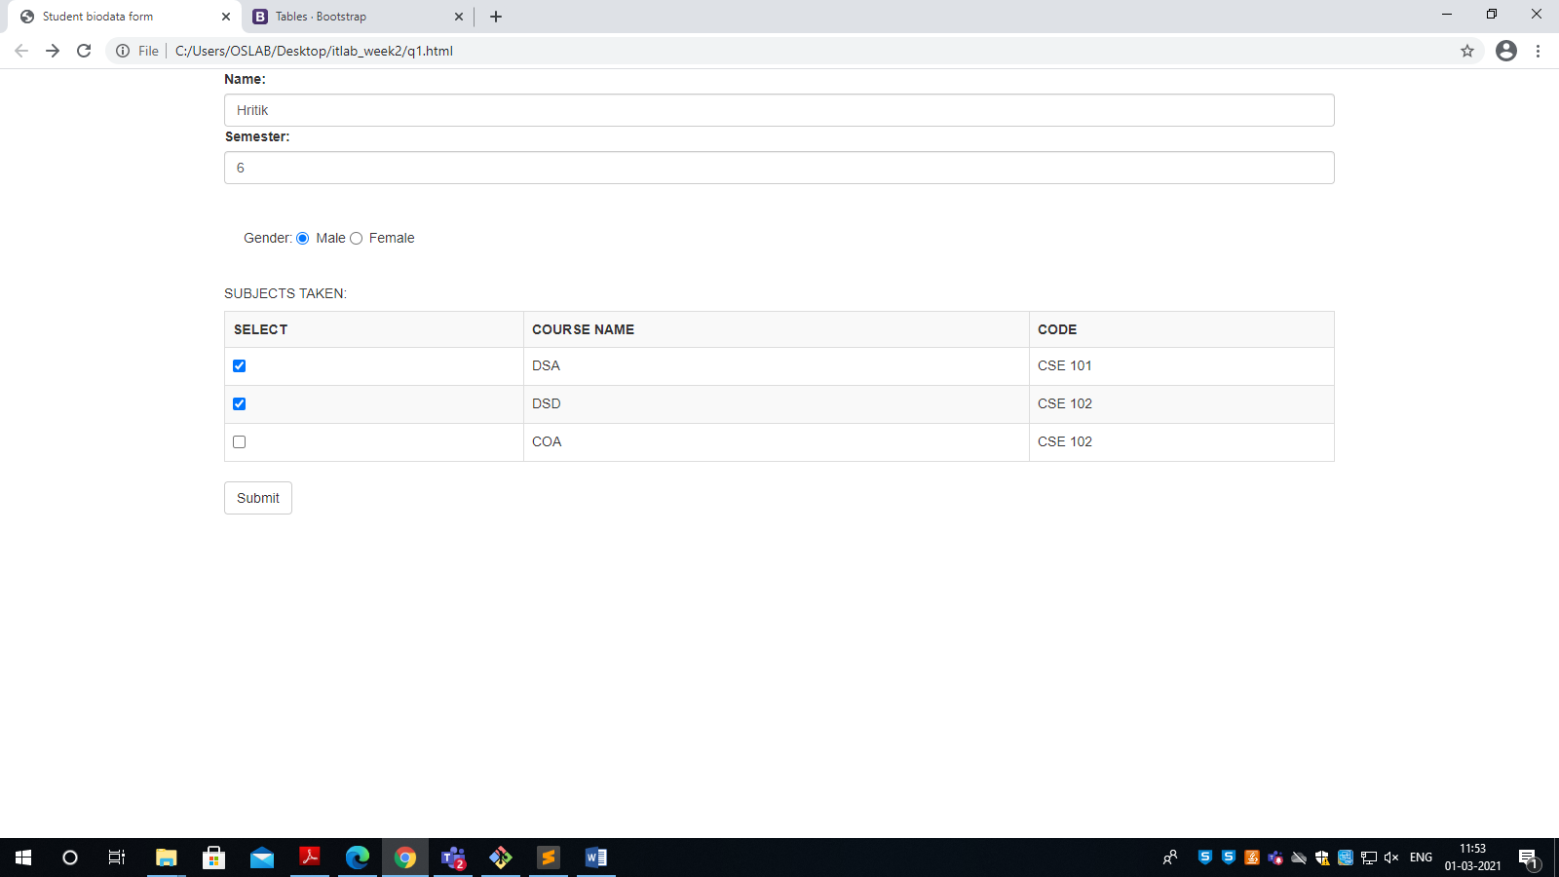

Q2)

OUTPUT:

Q3)

OUTPUT:

Q4)

<!DOCTYPE html>

<html>

<head>

<title>TIMETABLE</title>

<meta charset="utf-8">

<meta name="viewport" content="width=device-width, initial-scale=1">

<link rel="stylesheet" href="https://maxcdn.bootstrapcdn.com/bootstrap/4.5.2/css/bootstrap.min.css">

<script src="https://ajax.googleapis.com/ajax/libs/jquery/3.5.1/jquery.min.js"></script>

<script src="https://cdnjs.cloudflare.com/ajax/libs/popper.js/1.16.0/umd/popper.min.js"></script>

<script src="https://maxcdn.bootstrapcdn.com/bootstrap/4.5.2/js/bootstrap.min.js"></script>

</head>

<body>

<div id="carouselExampleControls" class="carousel slide" data-ride="carousel">

<div class="carousel-inner">

<div class="carousel-item active">

<table class="table table-bordered table-striped table-sm">

<h1>SECTION A</h1>

<tr>

<th>DAY</th>

<th>8-9:30</th>

<th>10-11:30</th>

<th>2-3:30</th>

<th>4:5:30</th>

</tr>

<tr>

<td>MONDAY</td>

<td></td>

<td></td>

<td class="table-active">EEFM</td>

<td class="table-active">DS</td>

</tr>

</tr>

<tr>

<td>TUESDAY</td>

<td class="table-active">PCAP</td>

<td class="table-active">PE 1</td>

<td></td>

<td></td>

</tr>

</tr>

<tr>

<td>WEDNESDAY</td>

<td></td>

<td></td>

<td class="table-active">PE 2</td>

<td class="table-active">OE 3</td>

</tr>

<tr>

<td>THURDAY</td>

<td class="table-active">PCAP</td>

<td class="table-active">DS</td>

<td></td>

<td></td>

</tr>

<tr>

<td>FRIDAY</td>

<td></td>

<td></td>

<td class="table-active">OE 3</td>

<td class="table-active">DS</td>

</tr>

<tr>

<td>SATURDAY</td>

<td class="table-active">PE 1</td>

<td class="table-active">PE 2</td>

<td></td>

<td></td>

</tr>

</table>

</div>

<div class="carousel-item">

<table class=" table table-bordered table-striped table-dark table-sm">

<h1>SECTION B</h1>

<tr>

<th>DAY</th>

<th>8-9:30</th>

<th>10-11:30</th>

<th>2-3:30</th>

<th>4:5:30</th>

</tr>

<tr>

<td>MONDAY</td>

<td></td>

<td></td>

<td class="table-active">EEFM</td>

<td class="table-active">DS</td>

</tr>

</tr>

<tr>

<td>TUESDAY</td>

<td class="table-active">PCAP</td>

<td class="table-active">PE 1</td>

<td></td>

<td></td>

</tr>

</tr>

<tr>

<td>WEDNESDAY</td>

<td></td>

<td></td>

<td class="table-active">PE 2</td>

<td class="table-active">OE 3</td>

</tr>

<tr>

<td>THURDAY</td>

<td class="table-active">PCAP</td>

<td class="table-active">DS</td>

<td></td>

<td></td>

</tr>

<tr>

<td>FRIDAY</td>

<td></td>

<td></td>

<td class="table-active">OE 3</td>

<td class="table-active">DS</td>

</tr>

<tr>

<td>SATURDAY</td>

<td class="table-active">PE 1</td>

<td class="table-active">PE 2</td>

<td></td>

<td></td>

</tr>

</table>

</div>

<div class="carousel-item">

<table class="table table-sm">

<h1>SECTION C</h1>

<tr>

<th>DAY</th>

<th>8-9:30</th>

<th>10-11:30</th>

<th>2-3:30</th>

<th>4:5:30</th>

</tr>

<tr>

<td>MONDAY</td>

<td></td>

<td></td>

<td class="table-active">EEFM</td>

<td class="table-active">DS</td>

</tr>

</tr>

<tr>

<td>TUESDAY</td>

<td class="table-active">PCAP</td>

<td class="table-active">PE 1</td>

<td></td>

<td></td>

</tr>

</tr>

<tr>

<td>WEDNESDAY</td>

<td></td>

<td></td>

<td class="table-active">PE 2</td>

<td class="table-active">OE 3</td>

</tr>

<tr>

<td>THURDAY</td>

<td class="table-active">PCAP</td>

<td class="table-active">DS</td>

<td></td>

<td></td>

</tr>

<tr>

<td>FRIDAY</td>

<td></td>

<td></td>

<td class="table-active">OE 3</td>

<td class="table-active">DS</td>

</tr>

<tr>

<td>SATURDAY</td>

<td class="table-active">PE 1</td>

<td class="table-active">PE 2</td>

<td></td>

<td></td>

</tr>

</table>

</div>

</div>

<a class="carousel-control-prev" href="#carouselExampleControls" role="button" data-slide="prev">

<span class="carousel-control-prev-icon" aria-hidden="true"></span>

<span class="sr-only">Previous</span>

</a>

<a class="carousel-control-next" href="#carouselExampleControls" role="button" data-slide="next">

<span class="carousel-control-next-icon" aria-hidden="true"></span>

<span class="sr-only">Next</span>

</a>

</div>

</body>

</html>

OUTPUT:  
